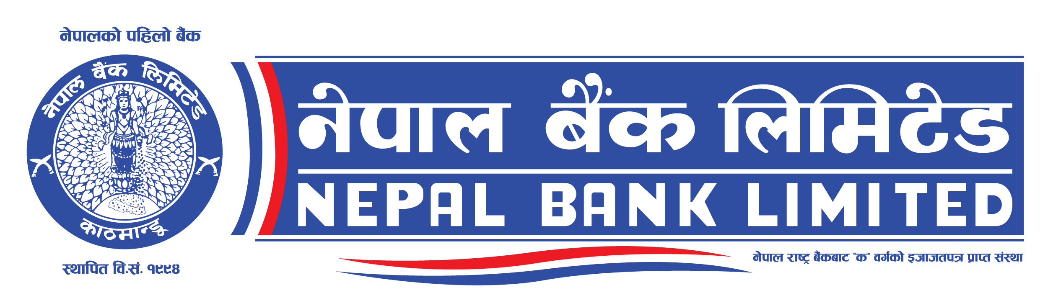
Invitation for Bids
Nepal Bank Limited
Head Office
General Services Department
Invitation for Bids for the Civil, Electrical &Networking Work for Renovation of Lahan Branch, Siraha

Contract Identification No: NBL/NCB07/W078/79
Date of publication: 2078-07-03

- Nepal bank limited has allocated funds from its own resources towards the cost of following works and intends to apply the funds to cover eligible payments under the contract and is open to all eligible Nepalese bidders.
- Nepal bank limited invites electronic bids from eligible bidders for the following works.

IFB No. | Description of work | Cost of bidding document (NRs) | Bid bond amount (NRs) | Last date and time of Bid submission | Bid opening date and time | Estimate amount NRs (with VAT)
NBL/NCB07/W078/79 | Civil, Electrical &Networking Work for Renovation of Lahan Branch, Siraha | 3000.00 | 1,25,000.00 (Nepalese Rupees One Lakh Twenty Five Thousand only) | 2078-8-03  11:00 hrs | 2078-8-03 12:00 hrs | 48,75,330.05  (Nepalese Rupees Forty Eight Lakh Seventy Five Thousand Three Hundred Thirty and Paisa Five only).
- Eligible Bidders may obtain further information and inspect the Bidding Documents at Nepal Bank Limited, Head Office, General Services Department, Kathmandu, Bagmati Province, Nepal during office hours or may visit PPMO website www.bolpatra.gov.np/egp.
- A complete set of bidding document is available online and can be downloaded from e-GP system: www.bolpatra.gov.np/egp . Interested bidders shall register in the e-GP system and deposit the above mentioned cost of bidding document in the Nepal Bank Limited , Kathmandu Banking Office, revenue account no.00200106711283000001
- Electronic bids must be submitted to the office of Nepal Bank Limited, Head Office, General Services Department, Kathmandu Bagmati Province, through PPMO website www.bolpatra.gov.np/egp on or before above mentioned date and time . Bids received after this deadline will be rejected.
- The bids will be opened in the presence of bidders’ representatives who choose to attend on above mentioned date and time at the Nepal Bank Limited, Head Office, General Services Department, Kathmandu, Bagmati Province, Nepal. Bids must be valid for the period of 90 days after bid opening and must be accompanied by scanned copy of the bid security in pdf format in case of e-bid, amounting as mentioned above, which shall be valid for 30 days beyond the validity period of the bid (total 120 days).
- The bid security may either be in the form of a bid security issued by authorized Bank and Financial institution according to the format provided in Bid Document or cash deposited in Nepal Bank Limited, Kathmandu Banking Office, NBL Bid Security Deposit Account 00200106711280000001
- The Employer reserves the right to accept or reject any bid, and to annul the bidding process and reject all bids at any time prior to contract award, without thereby incurring any liability to Bidders.

