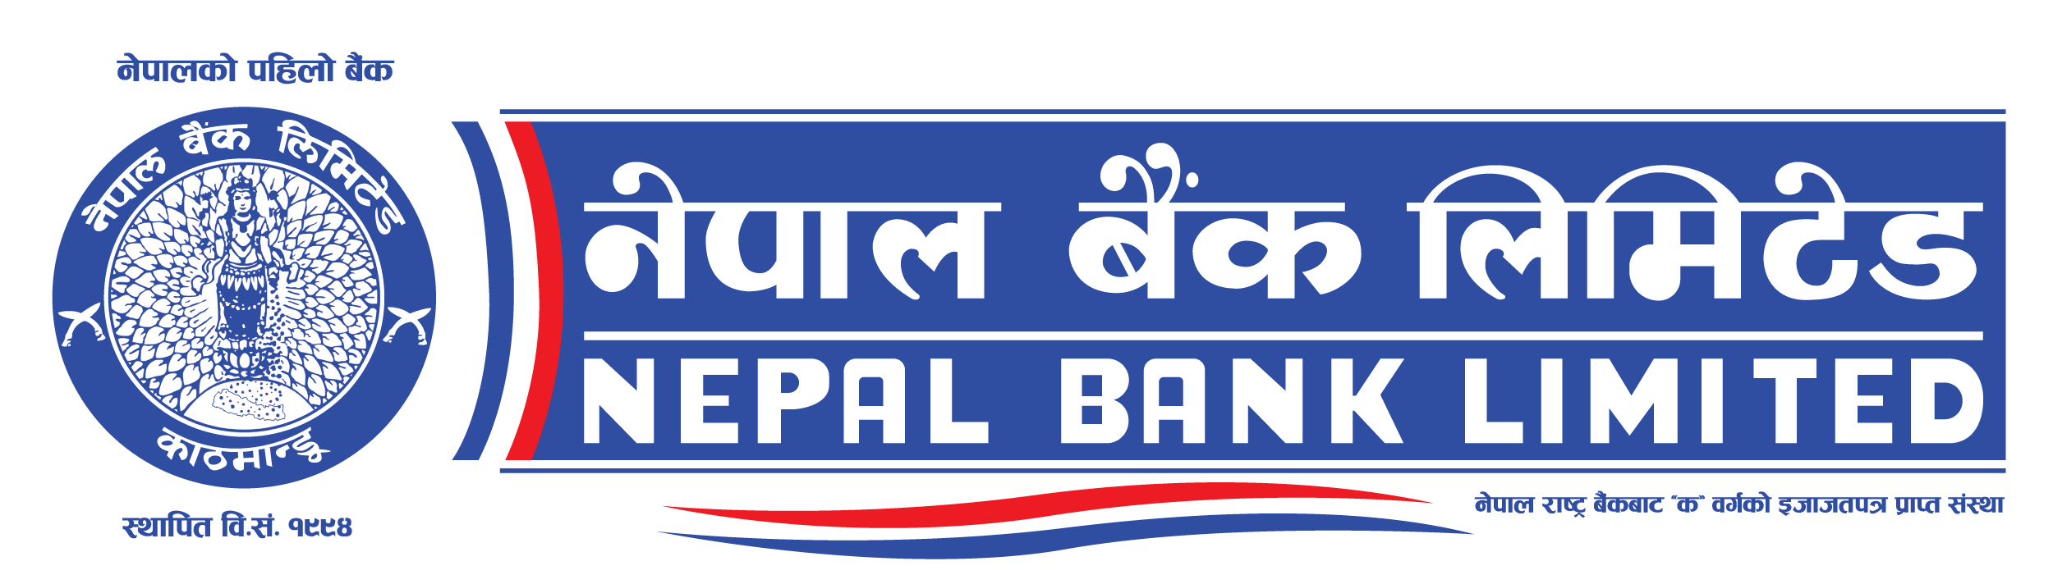

Nepal Bank Limited
Head Office

Invitation for bids for Supply of International Database

Date of publication: 7 January, 2024

Contract Identification No: NBL/ICB01/G080/81

- Nepal Bank Limited (NBL) has allocated its budget towards the cost of International Screening Database and intends to apply part of the funds to cover eligible payments under the Contract for International Screening Database, IFB No: NBL/ICB01/G080/81 Bidding is open to all eligible Bidders from all countries.
- The Bank invites electronic bids from eligible bidders for the procurement of International Screening Database under International Competitive Bidding – Single Stage Two Envelope.
- Under the Single Stage, Two Envelope Procedure, Bidders are required to submit simultaneously two separate sealed envelopes, one containing (i) the Technical Bid and the other (ii) the Price Bid, both in turn enclosed in one sealed envelope as per the provision of ITB 23 of the Bidding Document.
- Eligible Bidders may obtain further information and inspect the bidding documents by visiting PPMO egp system www.bolpatra.gov.np/egp.
- Bidder who chooses to submit their bid electronically may download the bidding documents for e-submission from PPMO’s e-GP system www.bolpatra.gov.np/egp. Bidders, submitting their bid electronically, should deposit the cost of bidding document (Nrs.3,000.00) in the following revenue account as specified below.
Information to deposit the cost of bidding document in Bank:
Name of the Bank: Nepal Bank Limited Name of Office: Kathmandu Banking Office
Office Account Name : NBL Tender/Sealed Quotation/Listing
Office Account no.: 00200106711283000001
- Electronic bids must be submitted to the office Nepal Bank Limited, General Service Department through PPMO’s e-GP system www.bolpatra.gov.np/egp on or before 12:00 noon on 21 Feb, 2024. Bids received after this deadline will be rejected.
- The bids will be opened in the presence of Bidders' representatives who choose to attend at 12:30 PM on 21 Feb, 2024 at the office of General Service Department, Head Office, Nepal Bank Limited. Bids must be valid for a period of 90 days from the date of bid opening and must be accompanied by a bid security or scanned copy of the bid security in pdf format in case of e-bid, amounting to a minimum of NRs. 60,000.00, which shall be valid for 30 days beyond the validity period of the bid (19 June, 2024)
- If the last date of purchasing and /or submission falls on a government holiday, then the next working day shall be considered as the last date. In such case the validity period of the bid and bid security shall remain the same as specified for the original last date of bid submission.

