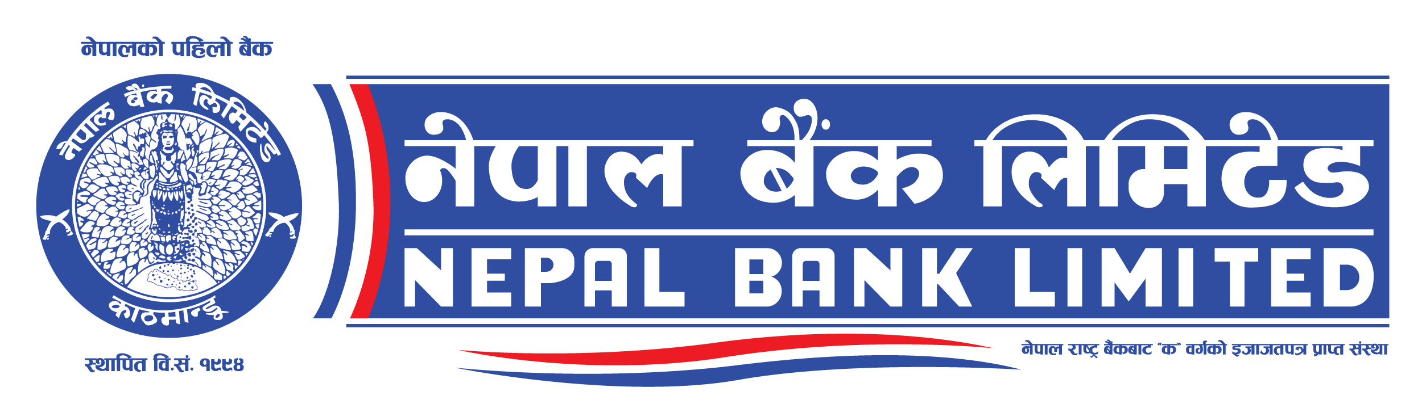
Head Office
General Service Department

Call for Proposal
Second date of publication: 16 May, 2024 (2081/02/03)

Name of Project: “Supply, Installation and Commissioning of Centralized Web Based Core Banking Solution”
Nepal Bank Ltd request for Proposal from Experts/Consultants.
S.N. | Name of Contract | Contract No
1 | Procurement Consultancy service for Evaluation of proposals. | NBL/RFP06/C080/81
2 | Legal Consultancy service for Evaluation of proposals. | NBL/RFP07/C080/81

Qualified and interested consultants are requested to submit their proposal in prescribed format to General Service Department, Nepal Bank Limited, Bhugolpark, Kathmandu by 24 May, 2024 (i.e. 2081/02/11) mentioning the subject as “Proposal for Procurement Consultancy service for Evaluation of Proposals” for Procurement consultant and “Proposal for Legal Consultancy service for Evaluation of Proposals” for Legal Consultant respectively. Terms of Reference and Scope of projects can be downloaded from bank website : https://www.nepalbank.com.np. For further details please contact : Mr. Dipendra Raj Kafle, Phone no: 01-5971135, 9851120022.

